Foodbank Hunger Report 2025
Template posts for social media with key stats and tiles

Remember to tag us | and include hashtags
- Instagram: @foodbankaus  - LinkedIn: @Foodbank Australia  - Facebook: @Foodbank Australia  - Twitter: @FoodbankAus | #ZeroHunger FoodbankHungerReport2025 #FoodRelief #BeKind
Renting households
Caption | Graphic
Australia’s housing crisis is driving food insecurity to alarming levels.  In the past year, 1 in 2 renting households (48%) have struggled to put food on the table.  With Foodbanks operating nationwide they are making sure no community is left behind when it comes to food relief. We’re proud to continue supporting Foodbank as they stand with the millions of households doing it tough. | 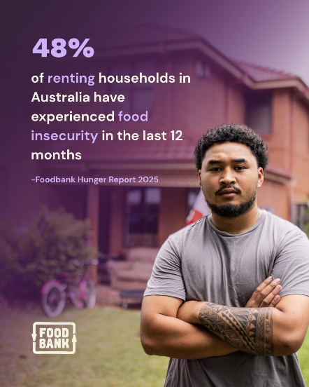  - View/download: AUS - Renting Households.png
Disability/Health issues
Caption | Graphic
Sadly, 75% of these households are in the severe category, meaning they are regularly skipping meals or going entire days without food.  It's a stark reminder of the ongoing challenges faced by too many in Australia. Foodbank remains dedicated to making a difference, ensuring food relief is accessible to those who need it most.  We are proud supporters of Foodbank and their mission of ending hunger in Australia. | - View/download: AUS - Disability_Health issues HH.png  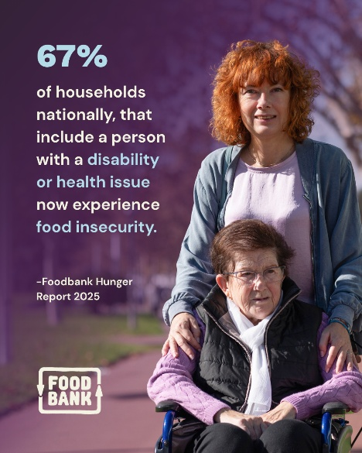
Households earning >$91K p.a
Caption | Graphic
One in five Australian households earning $91,000 or above have experienced food insecurity in the past year.  Food insecurity is not just impacting the lowest-income households — it’s affecting families right across the country.  We’re proud to partner with Foodbank as they work to ensure no one goes without. Read the Foodbank Hunger Report 2025 to see the true scale of the crisis. | 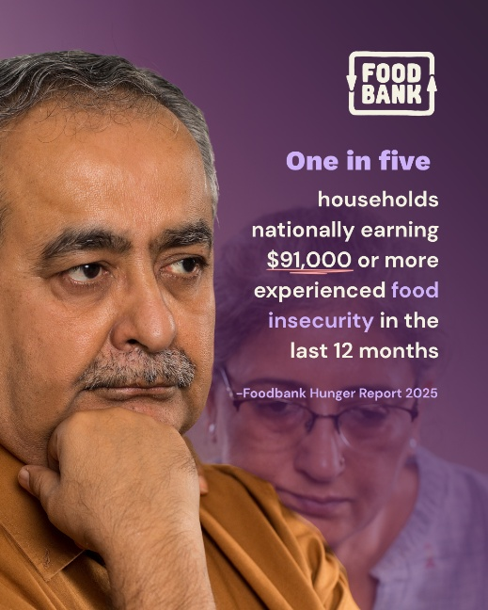  - View/download: AUS - HHs earning ≥ $91K p.a.png
Single Parent Household
Caption | Graphic
Single-parent households remain one of the most at-risk groups in Australia when it comes to food insecurity.  Alarming new findings show that almost half are now experiencing severe food insecurity – meaning they are regularly skipping meals or going entire days without food.  Foodbank remains dedicated to making a difference, ensuring food relief is accessible to those who need it most.  We are proud supporters of Foodbank and their mission of ending hunger in Australia. | 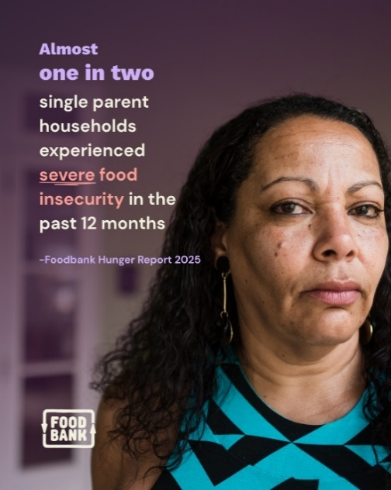  - View/download: Single Parent Household (AUS).png
Total food insecure households
Caption | Graphic
That’s almost 3.5 million households throughout Australia who have experienced food insecurity in the past 12 months.  Put simply, millions of families, children, individuals, students, pensioners; people in our very own communities, continue to face the distressing question of what, if anything, they can put on the dinner table.  We’re proud to partner with Foodbank, who works with 3,649 schools and 2,966 charities to ensure no one goes without. | 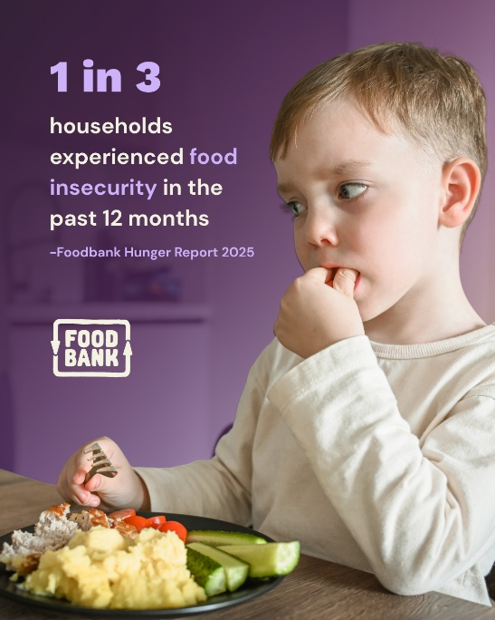  - View/download: AUS - Total food insecure.png
Cost-of-living
Caption | Graphic
The cost of living is the number one concern for 91% of food insecure households, followed by housing and the economy.  This year’s Foodbank Hunger Report shows just how deeply the cost-of-living crisis is impacting Australians.  We’re proud to partner with Foodbank in their mission to ensure no one goes without. | 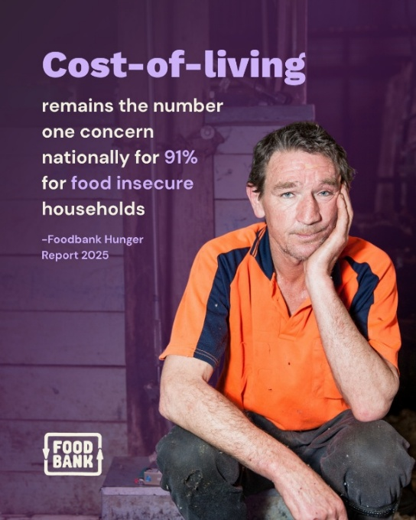  - View/download: AUS -Cost of living.png

